* -: Not only can you listen to the updates in your forum.
* You can ***also update the forum on your own***.
* Just like in the template driven approach***, set value and patch value are there for you.***
* I will quickly show it here.
* You can of course, on your forum as a whole, ***call set value and pass a JavaScript object.***
* Which should now resemble the object structure up here when you create the forum.
* So where you have your user data, which then is an object, where you have your username, and set is equal to Max, for example.
* Have your email set is equal to max@test.
* com.
* Have your gender, male.
* And of course your hobbies, potentially an empty array.

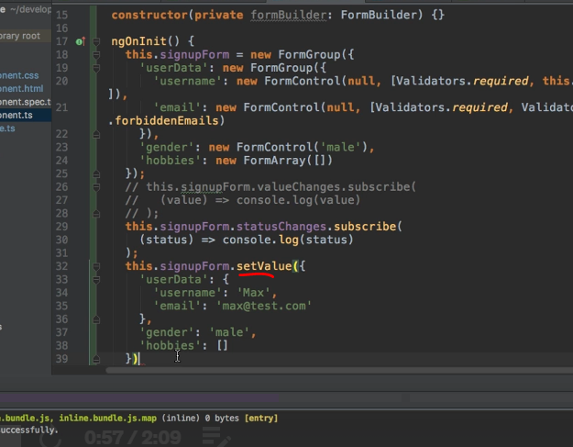

* So, if we do this, we should see that now, our form is pre-populated with some values, because we immediately call **set value.**

* And of course you can also call this up on the click of a button.
* And as in the template driven approach, you also have **patch value.**
* Of course**, if you only want to update a part of the** form like for example, the username, switch this to Anna.

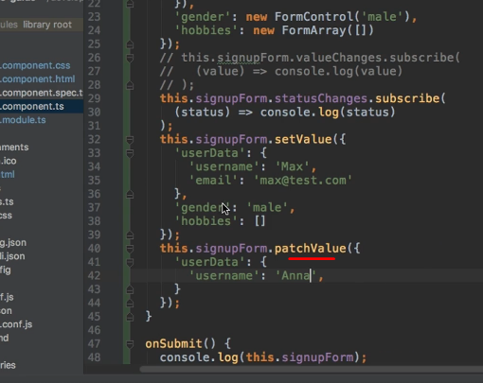

* Now you should see that the username, is changed to Anna.

* The rest still contains the values I set with set value.
* So, just to bring this to your attention.
* Patch value and set value are also available.
* And the same is true for **resetting.**
* So, if you want to reset the form after submitting it, we can simply call reset here.

* So, let's quickly do this, and hit submit.
* Now it's gone.
* So, this empties our form.

* Now, with that, you should have the tools to work with the form, to configure it to your needs, and to really build powerful forms.
* Time to practice this, in the next assignment.